1.Create a namespace dev-environment and apply a resource-based quota that restricts the number of pods to 3 and services to 2.
Steps:
- Create namespace
Kubectl create ns dev-environment
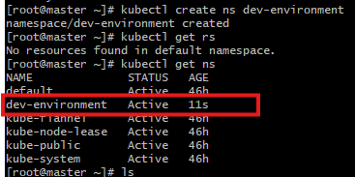

- Create ResourceQuota YAML
Vi quota.yaml
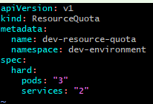

- Deploy the yaml file
Kubectl apply -f quota.yaml
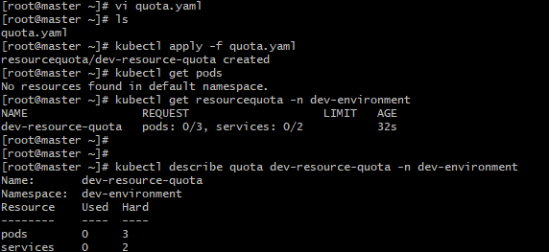
2. Create a pod in the prod-environment namespace with 0.2 CPU and 200Mi memory requests, and 0.5 CPU and 500Mi memory limits.

Steps:

- Create a namespace
Kubectl create ns prod-environment

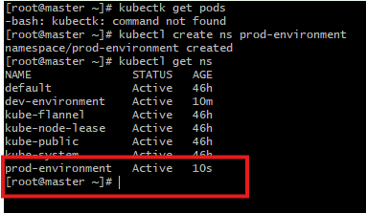

- Create Pod YAML
Vi prod.yaml
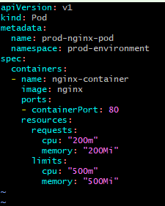

- Deploy the pod
Kubectl apply -f prod.yaml

Describe the pod
Kubectl describe pod prod-nginx-pod -n prod-environment

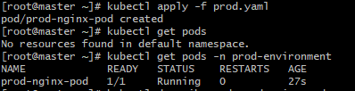
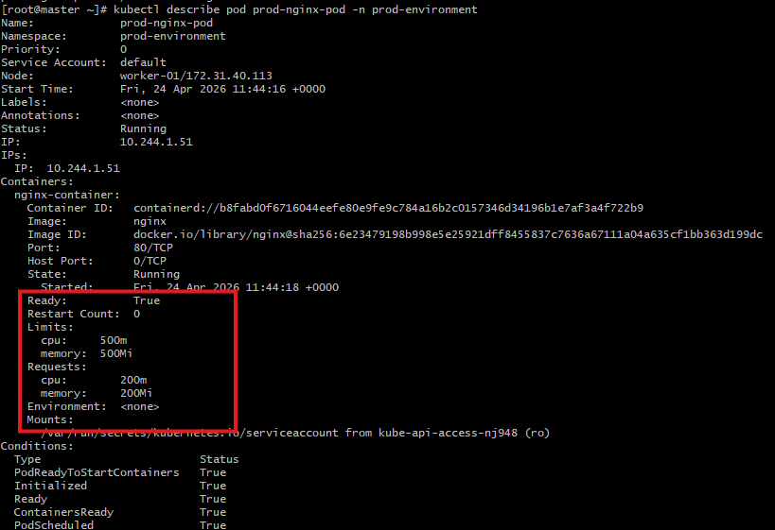
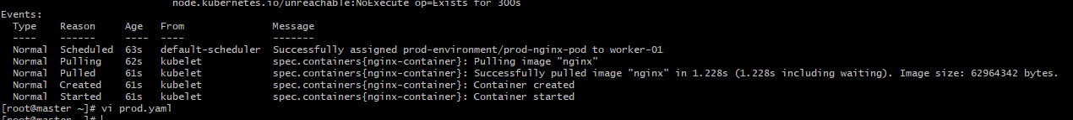

3. In the staging-environment namespace, set a LimitRange that assigns default CPU and memory limits (300m CPU, 600Mi memory) and applies a minimum and maximum CPU.
Steps:
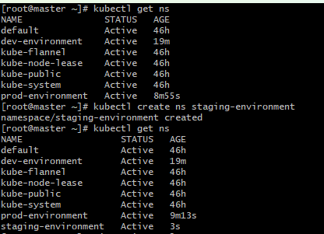

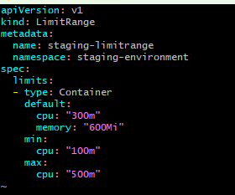

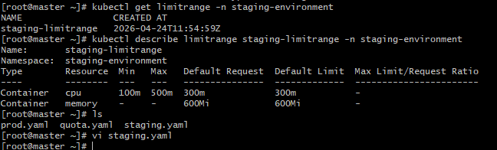

4. Create a pod and a NodePort service in the default namespace, then create another pod in the test namespace and communicate between them using Service DNS.
Steps:
- Create a nginx pod using default namespace
Vi nginx.yaml
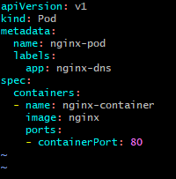

- Deploy the pod
Kubectl apply -f nginx.yaml
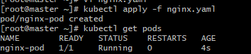

- Create NodePort Service in default namespace
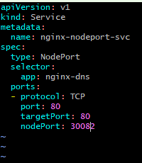
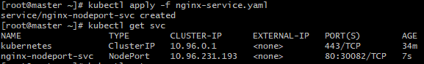

- Create a test namespace
Kubectl create ns test
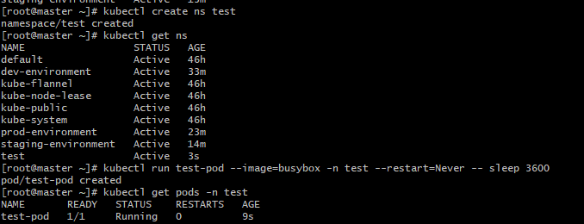

5. Apply a LimitRange with a max limit/request ratio of 2 for memory in the performance-environment namespace, and test by creating a pod with mismatched resource requests and limits.
Steps:
- Create namespace
Kubectl create ns performance-environment
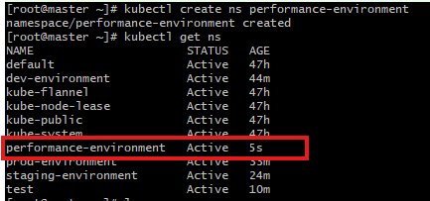

- Create LimitRange YAML
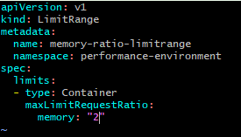

- Deploy the limitrange
Kubectl apply -f limitrange.yaml
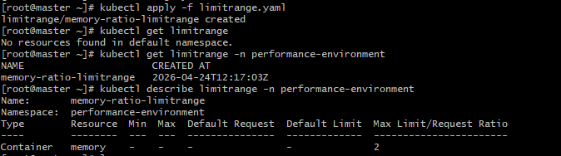

- Create a valid Pod
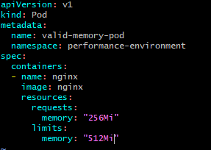

- Deploy the pod
Kubectl apply -f memory.yaml
